**LED Indicators**

**Introduction to LED:**

LED stands for Light Emitting Diode. It's a semiconductor device that emits light when an electric current passes through it. LEDs are commonly used in various applications such as lighting, displays, indicators, and more. They are known for their energy efficiency, long lifespan, and durability compared to traditional light sources like incandescent bulbs or fluorescent lamps. LEDs come in different colors and can be found in a wide range of products, from everyday household lighting to advanced electronic displays.

The structure and construction of Light Emitting Diodes are much different from that of a regular semiconductor signal diode. Light will be emitted from the LED when its PN junction is forward biased. The PN junction is covered by a transparent solid and plastic epoxy resin hemispherical shaped shell body which protects the LED from atmospheric disturbances, vibrations and thermal shock. The PN junction is formed using the lowest band gap materials like Gallium Arsenide, Gallium Arsenide Phosphide, Gallium Phosphide, Gallium Indium Nitride, Aluminum Gallium Nitride, Silicon Carbide etc.

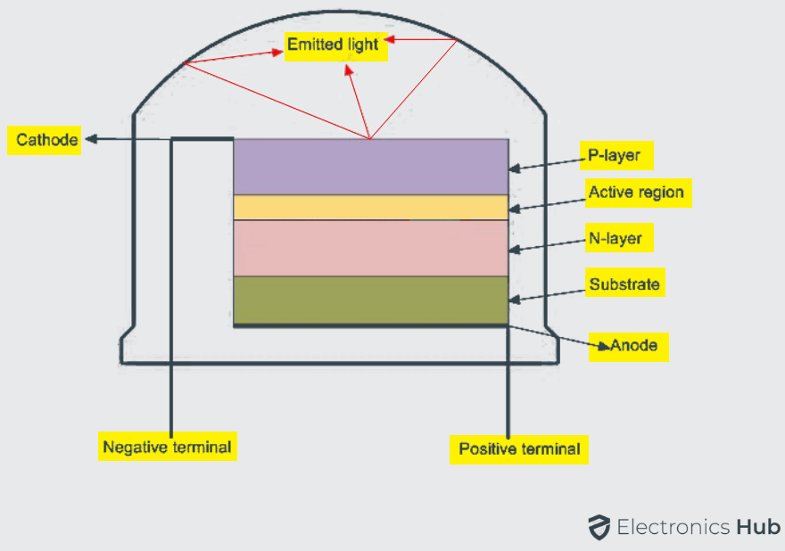

.

Actually an LED junction does not emit much amount of light so that the epoxy resin body is built in such a way that the photons of light emitted by the junction are reflected away from the surrounding substrate base and are focused through the domed top of the LED, which itself acts as a lens concentrating the larger amount of light. It is the reason why the emitted light appears to be brightest at the top of the LED.

**WORKING OF LED :**

It works on the principle of photoelectric effect. The photoelectric effect is a phenomenon that occurs when light causes electrons to be ejected from a material. The electrons emitted in this way are called photoelectrons. The kinetic energy of the photoelectrons depends on the frequency of the incident light. The photoelectric effect can be explained by considering light as a stream of particles called photons. The energy of a photon is related to its frequency.

A Light emitting diode bulb consists of two semiconducting materials i.e. p-type material and n-type material. A p-n junction is formed, by connecting these two types of materials.

When the p-n junction is forward biased, the majority carriers; either electrons or holes; start moving across the junction. As shown in the figure below, electrons start moving from n-region and holes start moving from p-region. When they move from their regions they start to recombine across the depletion region. Free electrons will remain in the conduction band of energy level while holes remain in the valence band of energy level.

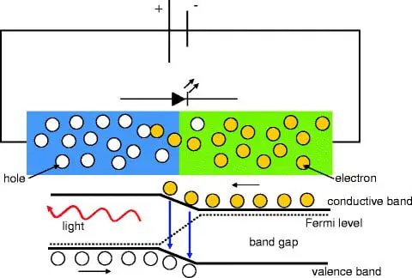

The Energy level of the electrons is higher than holes because electrons are more mobile than holes i.e. current conduction due to electrons are more. During the recombination of electrons and holes, some portion of energy must be dissipated or emitted in the form of heat and light. The phenomenon into which light emits from the semiconductor under the influence of the electric field is known as electroluminescence. Always remember that the majority of light is produced from the junction nearer to the p-type region. So diodes are designed in such a way that this area is kept close to the surface of the device to ensure that the minimum amount of light is absorbed.

The electrons dissipate energy in different forms depending on the nature of the diode used. Like for silicon and germanium diodes, it dissipates energy in the form of heat while for gallium phosphide (GaP) and gallium arsenide phosphide (GaAsP) semiconductors, it dissipates energy by emitting photons. For the emission of different colors, different semiconductors are used. For example; phosphorus is used for a red light, gallium phosphide for the green light and aluminum indium gallium phosphide for yellow and orange light.

**Specifications of LED:**

* Operating Voltage: 12V DC
* Power: 1.5w
* Operating Temperature: 20 to 60 Celsius
* Power Dissipation: 0.72 to 2W

# **Introduction to Battery:**

A battery is a device that stores energy in one or more electrochemical cells and converts it into electrical power. Batteries use an electrochemical oxidation-reduction (redox) reaction to transfer electrons from one material to another via an electric circuit. Batteries are commonly used in households, such as in flashlights, and are usually made of dry cells.

In dry cells, the chemicals that produce the current are made into a paste. In other batteries, such as car batteries, these chemicals are in liquid form. Batteries are electrochemical devices that store and release energy through chemical reactions. There are two main types of batteries: primary batteries and secondary batteries (rechargeable batteries).

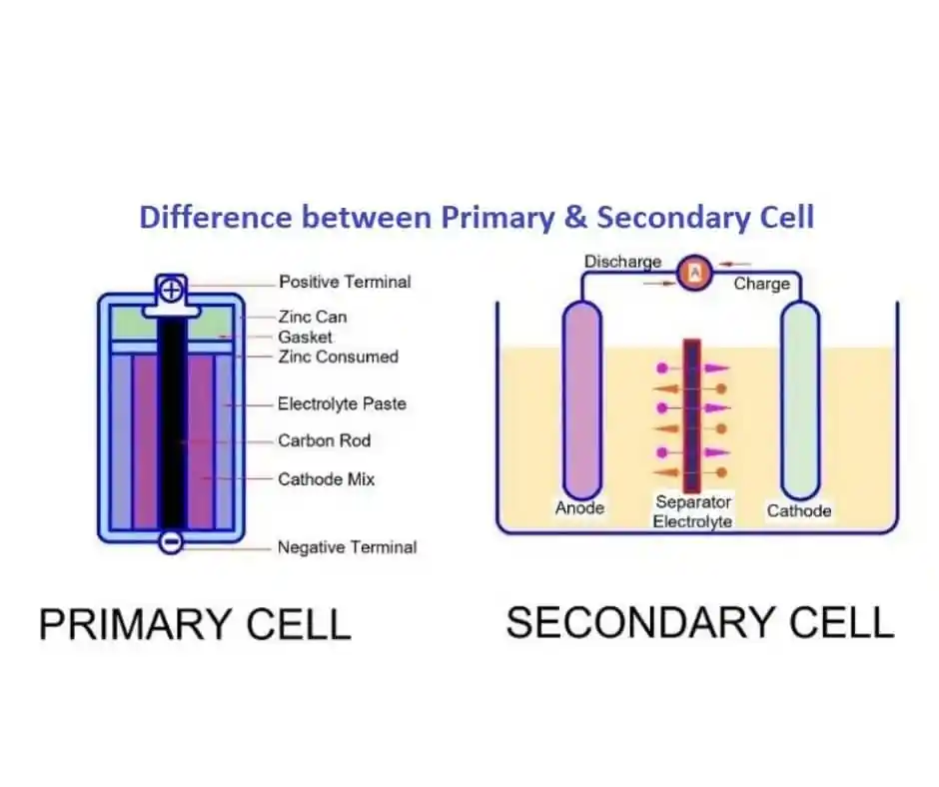

**Fig: *Primary and Secondary batteries***

* **Primary Batteries:**

Primary batteries are single-use batteries that cannot be recharged once they are depleted. They typically use non-reversible chemical reactions to produce electricity. Common examples include alkaline batteries, zinc-carbon batteries, and lithium primary batteries. Primary batteries are commonly used in devices where long-term reliability and convenience are more important than the cost of replacement. They are often found in low-drain devices such as remote controls, flashlights, and smoke detectors.

* **Secondary Batteries (Rechargeable Batteries):**

Secondary batteries are rechargeable batteries that can be recharged and reused multiple times. They use reversible chemical reactions to store and release energy. Common examples include lithium-ion batteries, nickel-metal hydride (NiMH) batteries, and lead-acid batteries. Rechargeable batteries are used in a wide range of devices, including smartphones, laptops, electric vehicles, and renewable energy storage systems. Primary batteries are convenient for single-use applications with low power requirements, while rechargeable batteries offer a more sustainable and cost-effective solution for devices that require frequent use and higher energy demands.

# **Working of a battery:**

A battery works on the oxidation and reduction reaction of an electrolyte with metals. When two dissimilar metallic substances, called electrodes, are placed in a diluted electrolyte, oxidation and reduction reaction take place in the electrodes respectively depending upon the electron affinity of the metal of the electrodes. As a result of the oxidation reaction, one electrode gets negatively charged called cathode and due to the reduction reaction, another electrode gets positively charged called anode. The cathode forms the negative terminal whereas anode forms the positive terminal of a battery.

To understand the basic principle of battery properly, first, we should have some basic concept of electrolytes and electron affinity. When two dissimilar metals are immersed in an electrolyte, there will be a potential difference produced between these metals. It is found that, when some specific compounds are added to water, they get dissolved and produce negative and positive ions. This type of compound is called an electrolyte. The popular examples of electrolytes are almost all kinds of salts, acids, and bases etc.

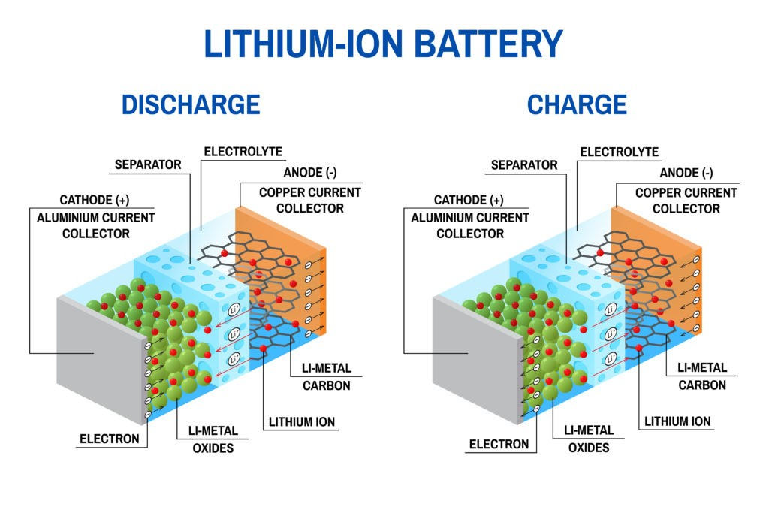

The energy released during accepting an electron by a neutral atom is known as electron affinity. As the atomic structure for different materials are different, the electron affinity of different materials will differ. If two different kinds of metals are immersed in the same electrolyte solution, one of them will gain electrons and the other will release electrons. Which metal (or metallic compound) will gain electrons and which will lose electrons, depend upon the electron affinity of these metals.

The metal with low electron affinity will gain electrons from the negative ions of the electrolyte solution. On the other hand, the metal with high electron affinity will release electrons and these electrons come out into the electrolyte solution and are added to the positive ions of the solution. In this way, one of these metals gains electrons and another one loses electrons. As a result, there will be a difference in electron concentration between these two metals. This difference in electron concentration causes an electrical potential difference developed between the metals. This electrical potential difference or emf can be utilized as a source of voltage in any electronics or electrical circuit.

# **Specifications of battery:**

* Discharge Time: 270hm, 9 hours
* Nominal Voltage : 9V
* Jacket Material: Metal
* Dimensions (mm) LxWxH: 4.5 x 2.2 x 1.5
* Weight: 178gms

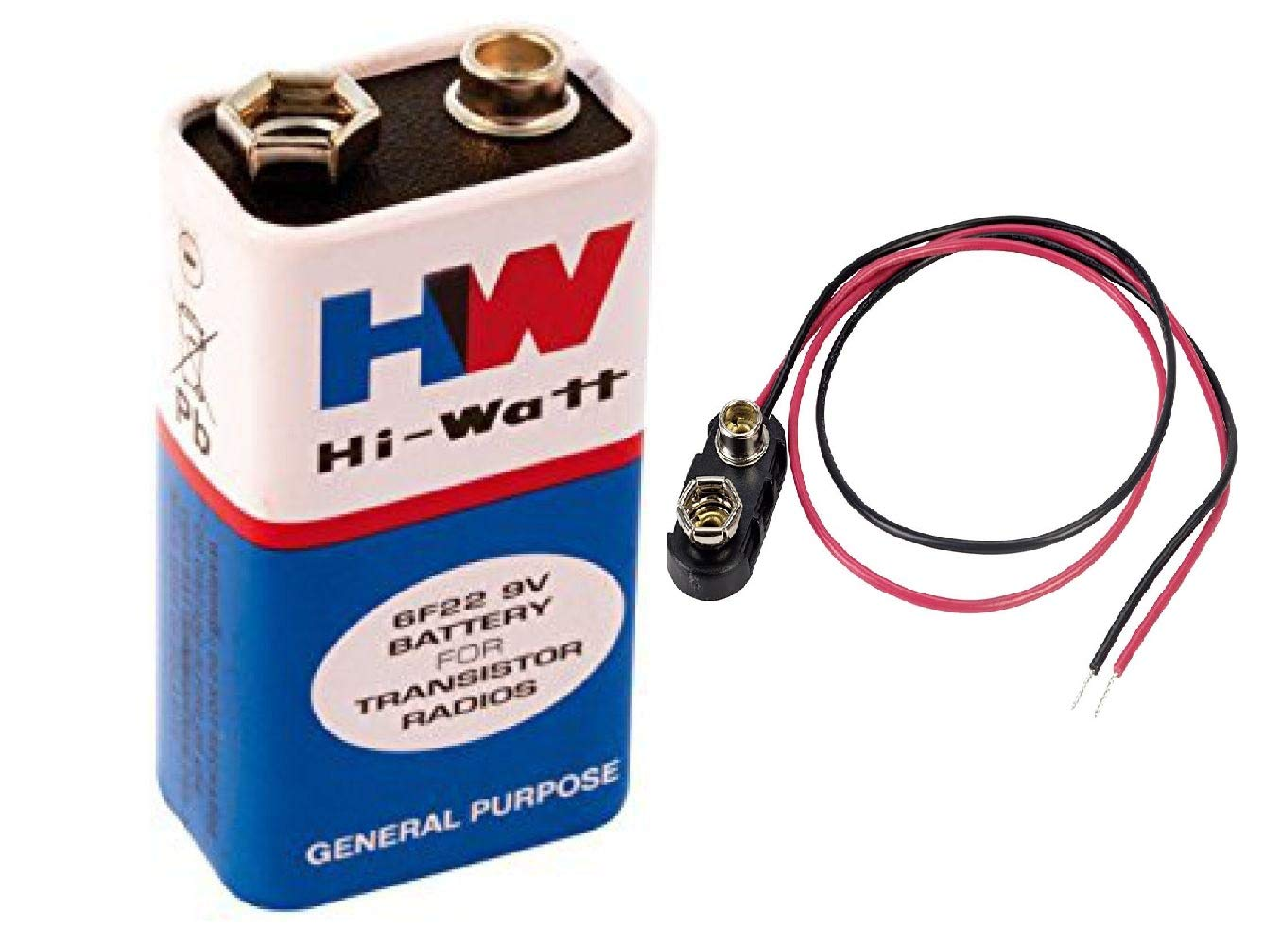

**LED Module:**

Light emitting diode (LED) modules are self-contained devices that contain a chain of LED emitters. They are the perfect lighting solution for a variety of applications, from channel letters and advertising to narrow profiles that are hard to reach with traditional bulbs, lamps or tubing. LED modules are a creative light source available in a variety of colors, brightness levels and beam angles. LED modules are made up of multiple LED emitters that are powered by a board and fixture. The assembly contains a semiconductor that emits light energy when energized.

The power can come from a battery or any other power source. LED modules are available in a variety of colors, brightness levels and beam angles. They can be plugged into other compatible units or can function alone. Some LED light modules, like linear light modules, can use a pin base connection, while others, like channel letter LED modules, connect to one another through a wire connection. Some offer an adhesive back to allow them to stick to a fixture during installation. LED light modules can fit a wide range of uses. They can operate alone or plug into a compatible fixture.

Certain LED light modules, like linear light modules, can use a pin base connection, while others, like channel letter LED modules, connect to one another through a wire connection. Some offer an adhesive back to allow them to stick to a fixture during installation. LED light modules can install into new fixtures or retrofit old fixtures. Some manufacturers make integrated LED module fixtures that can retrofit traditional bulb fixtures. Integrated LED fixtures offer new lighting designs. Without having to accommodate a traditional bulb style, manufacturers can create new and unique fixture designs.

# **Push button:**

A push button switch is a mechanical device that controls the flow of electricity in an electronic circuit by opening or closing contacts when the button is pressed or pulled. Push buttons are often made of metal or thermoplastic and are easy for users to access. Push buttons can be momentary or latching. Momentary push buttons return to their normal closed position after the button is released, while latching push buttons alternate between on and off with each press.

Push button switches rely on a simple in-out actuation mechanism. They can be employed to break (off) or initiate (on) a circuit. Alternatively, they can provide an input for the user interface of a piece of equipment or start/stop a particular function. Push button switches may be categorized as being either momentary (where the switch function only continues for as long as the operator is pushing the button) or maintained (where the switch function stays latched in that status after it has been actuated).

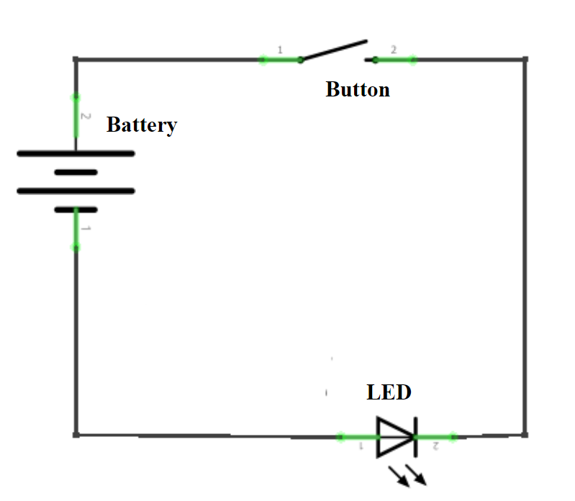

**Step1:**

Identify the components and make sure all of them are available for interfacing.

### **Required components:**

* LED Module
* Battery 9V
* Push button

**Step2:**

Give the connections as per the circuit diagrams given below.

**Step3:**

Make sure all the connections are firm and recheck them once again to avoid loose connections.

**Step4:**

Make two such circuits and attach them on either side of the cart.

**Step5:**

Push the button on any side and observe the LED turn on.

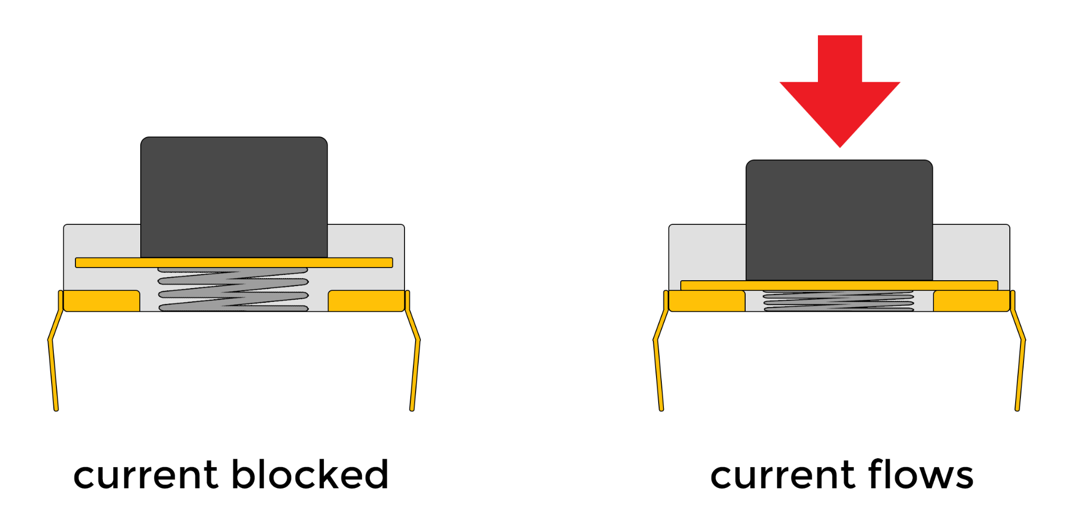

**Step6:**

Release the button and observe the LED turn off.